**Deadheads Limitation**

***Work-flow to Use Deadheads Limitation***

Use **Load Template** to set up the preference for several conditions



Repeat **Load Template** for additional instances of any template



***Preference Overview***

This is a set of complimentary preference instances that set distance limits for deadhead and depot pull out/ depot pull in trips. in order to minimize deadhead Km or to keep the vehicles close to their “home” depots.

***Templates Available from Optibus***

*Table 1-1: Templates Summary*

|  |  |  |
| --- | --- | --- |
| **Template Name** | **Purpose** | **Reference** |
| Reduce depot checks | Reduces the duration of the depot optimization by minimizing the number of depot “candidates”. | **Reduce depot checks** |
| Minimize Vehicle  Cruise Restriction | Set as a constraint, the maximum distance for a depot pull out. | **Minimize Vehicle**  **Cruise Restriction** |
| Minimize Vehicle  Cruise Preference | Set the maximum distance for a depot pull out with a penalty. | **Minimize Vehicle**  **Cruise Preference** |

Reduces the duration of the depot optimization by minimizing the number of depot “candidates”. **Prerequisites:** None.

**Opening Dialog:**

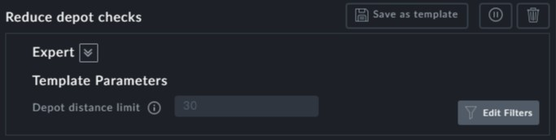

**Points to note:**

**Depot distance limit**: Specify the maximum distance limit for a depot pull in\out.



The unit of distance (Km, miles) depends on your location



Limit the deadhead distance for cruzing away from a depot (regarding a vehicle which performs a deadhead trip in order to perform a service trip which takes the vehicle even further away) **Prerequisites:** None.

**Opening Dialog:**

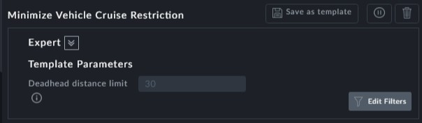

**Points to note:**

**Deadhead distance limit**: State the deadhead distance limit



The unit of distance (Km, miles) depends on your location



Limit the deadhead distance for cruzing away from a depot (regarding a vehicle which performs a deadhead trip in order to perform a service trip which takes the vehicle even further away) . Set with a penalty.

**Prerequisites:** None.

**Opening Dialog:**

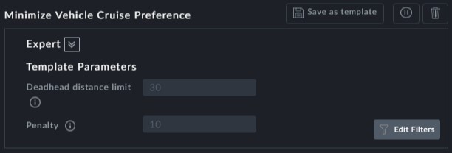

**Points to note:**

This preference is a flexible version of **Minimize Vehicle Cruise Restriction**



**Deadhead distance limit**: State the deadhead distance limit



The unit of distance (Km, miles) depends on your location

